Upon running the actual algorithm, the algorithm seems to be a type of sort.

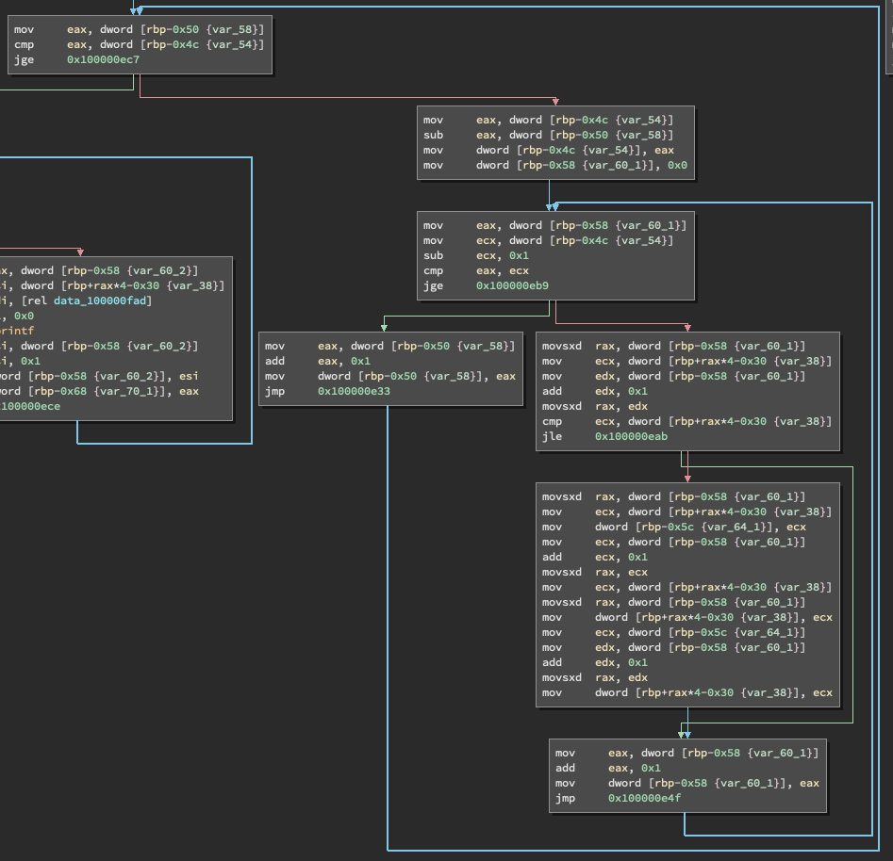Looking at the disassembled code, there seems to be multiple sets of loops.

Some of the loops seemed to be for scanning input and outputting the data

after being sorted. Also, it seems like for the algorithm there are two sets

of loops. On top of that it seems like it is a set of nested loops. This lead

me to believe it is a sorting algorithm of time complexity N^2. This is made

evident as two different variables are incremented by 1 on each iteration. This

leads limits the number of sorting algorithms to be bubble, selection and

insertion sort. Beyond this I cannot tell any further which algorithm was used.

If a guess had to be made, I would guess bubble as that tends to be the most

common basic sorting algorithm most people would implement.

